**Lab Assignment 6**

**Name – Abhijit Gawai**

**Roll no – 18 (Batch 1)**

**Gr no – 11810895**

**Problem Statement :** Write a useful and relevant PL/SQL trigger and cursor for your DBMS application.

INITIAL DATABASE:

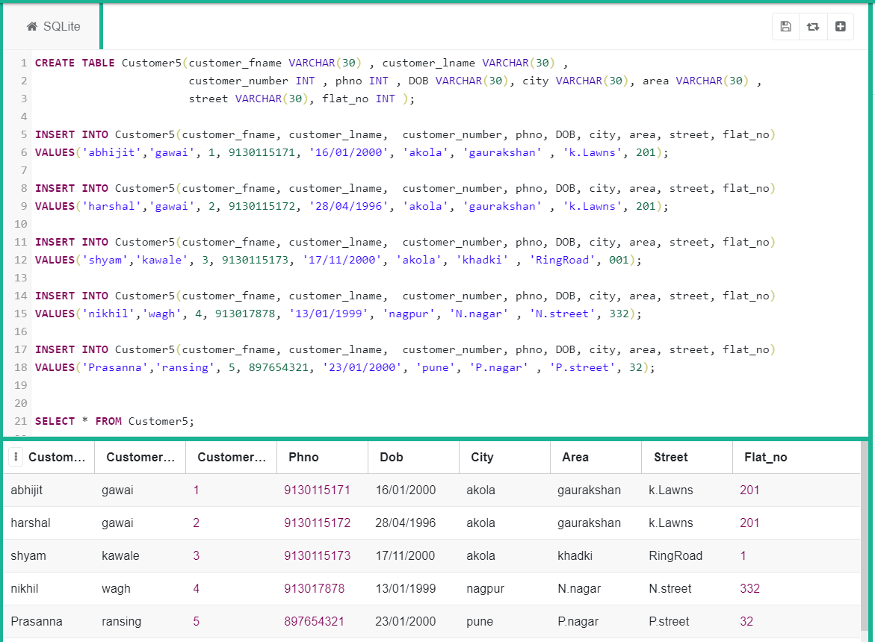

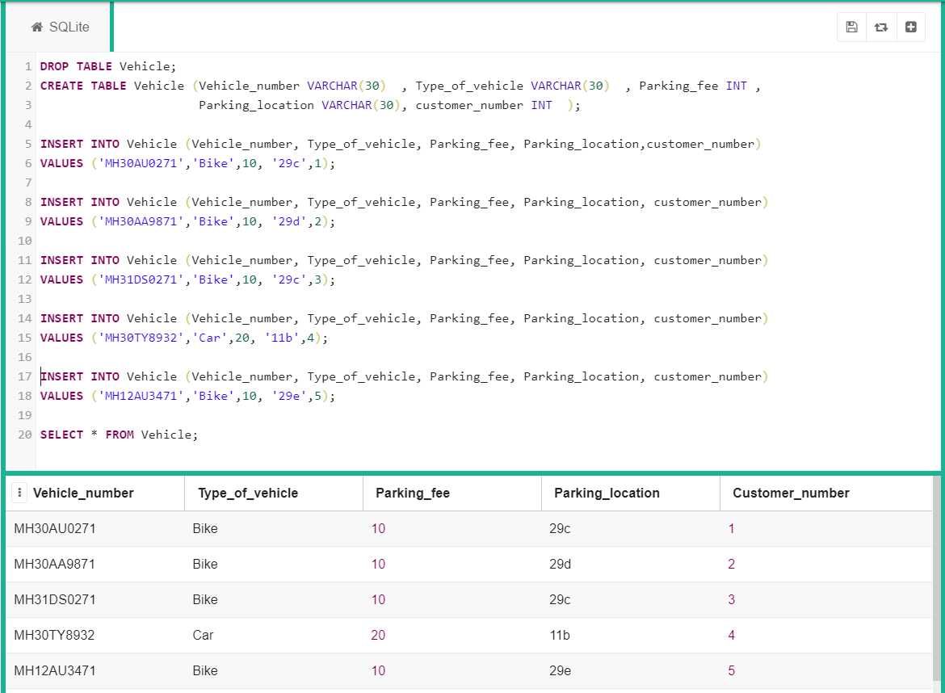

Functions:

Qwery: To get vehicle number by customer number

create or replace function get_vehicle_no(cnonumber number)

return varchar(10)

is

s number(10);

begin

select vehicle_number into s from Vehicle

where customer_number=cno;

retrun s;

end;/

select customer_number, get_vehicle_no(1) from Customer5;

output:

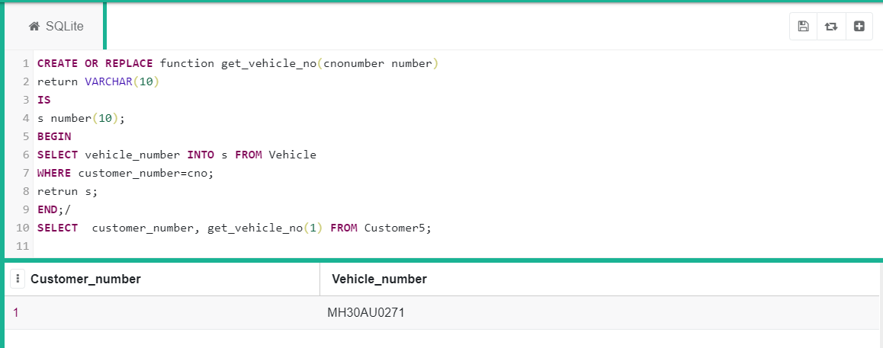

PROCEDURE:

Query: **To decrease Parking fee**

Create procedure decrease_parking_fee(Type_of_vehicle varchar(10),decrement number)

as

begin

update Vehicle set Parking_fee=Parking_fee-decrement where Type_of_vehicle=’car’;

commit;

select Parking_fee into S from Vehicle where Type_of_vehicle=’car’;

end;

execute decrease_parking_fee(‘bike’,5);

execute decrease_parking_fee(‘car’,5);

select * from Vehicle;

Output:

